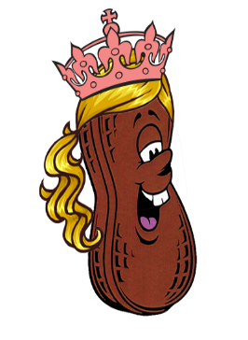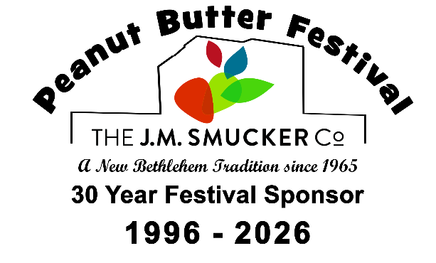
New Bethlehem Peanut Butter Festival
Redbank Valley Chamber of Commerce
309 Broad Street, Suite 2, New Bethlehem, PA 16242
(P) 814.275.3929, (C) 814.230.0069 (F) 814.275.4269
info@RedbankChamber.com | RedbankChamber.com

309 Broad Street, Suite 2
New Bethlehem, PA 16242
Phone 814.275.3929

Peanut Butter Festival Queen Scholarship Contest
Sponsored by THE J.M. SMUCKER CO.
Hosted by: Redbank Valley Chamber of Commerce
Rules for entering:
1. Entrant must be a resident of Redbank Valley School District.
2. Entrant must be a female at least 16 years old by September 20, 2026 and not exceed 19 years by the same date.
3. Entrant must be single, never married and have no children. Entrant must not be pregnant during the time of the contest.
4. Entrant must be available for appearances during the three-day festival, September 18, 19, & 20, 2026.
5. Entrant must attend all rehearsals and meetings.
6. Entrant will be judged according to three (3) categories:
-Written Essay - Thursday, August 20th or Friday August 21st at 9am.
-Poise and Presentation - Saturday, September 12th at 6pm at Gumtown Park
-Individual Question - Saturday, September 12th at 6pm at Gumtown Park
7. The winner of the contest will receive a $2,000 cash scholarship towards postsecondary education. The runner-up in the contest will receive a $1,000 cash scholarship towards postsecondary education.
8. Applications must be received by August 14, 2026. No late applications will be accepted. If there are an inadequate number of entrants, this contest may be canceled. All applications should be submitted to:
Redbank Valley Chamber of Commerce
c/o Gennie Gerow
309 Broad Street, Suite 2
New Bethlehem, PA 16242
Entrants must not have a family member employed at THE J. M. SMUCKER Co.

If you have any additional questions, please call Gennie @ 724-525-9844

